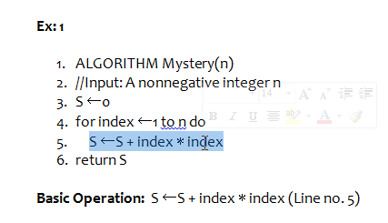

Basic operation is one which takes more CPU time. It is instruction in innermost loop.

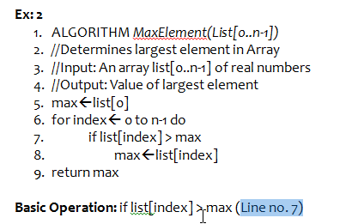

Efficiency of an algorithm.

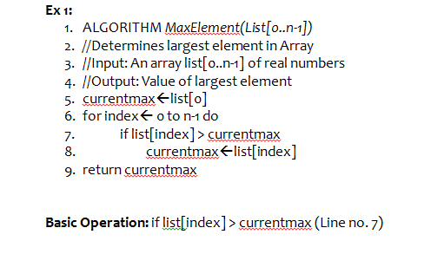

Efficiency is for a input size n, the basic operation is executing.

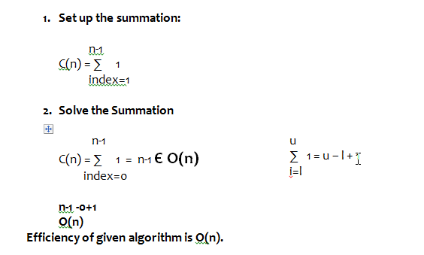

Index should be 0.

Generic formula is summation of i=l(lower bound) u = upper bound

1 is the basic operation.

n-1 is upper bound. 0 is lower bound. n-1-0+1. So -1 and 1 get cancelled. Hence only n remains.

Efficiency is Big O(n)

When algorithm is having one for loop we will have Efficiency is Big O(n)

When algorithm is having two for loop we will have Efficiency is Big O(n2)

When algorithm is having three for loop we will have Efficiency is Big O(n3)